Spring Boot -Spring Security -Oauth2

What is OAuth 2.0 and how it works?
OAuth doesn't share password data but instead uses authorization tokens to prove an identity between consumers and service providers. OAuth is an authentication protocol that allows you to approve one application interacting with another on your behalf without giving away your password.

What is OAuth 2.0 used for?
The OAuth 2.0 specification defines a delegation protocol that is useful for conveying authorization decisions across a network of web-enabled applications and APIs. OAuth is used in a wide variety of applications, including providing mechanisms for user authentication.

What is OAuth flow?
OAuth 2 is an authorization framework that enables applications to obtain limited access to user accounts on an HTTP service, such as Facebook, GitHub, and DigitalOcean. ... OAuth 2 provides authorization flows for web and desktop applications, and mobile devices.

When should you use OAuth?
You should only use OAuth if you actually need it. If you are building a service where you need to use a user's private data that is stored on another system — use OAuth
What is OAuth in REST API?
OAuth is an authorization framework that enables an application or service to obtain limited access to a protected HTTP resource. To use REST APIs with OAuth in Oracle Integration, you need to register your Oracle Integration instance as a trusted application in Oracle Identity Cloud Service.

Is OAuth a SSO?
OAuth (Open Authorization) is an open standard for token-based authentication and authorization which is used to provide single sign-on (SSO). OAuth allows an end user's account information to be used by third-party services, such as Facebook, without exposing the user's password.

Is OAuth safe?
It's the most secure flow because you can authenticate the client to redeem the authorization grant, and tokens are never passed through a user-agent. There's not just Implicit and Authorization Code flows, there are additional flows you can do with OAuth. Again, OAuth is more of a framework.

What does OAuth stand for?
Open Authorization
OAuth, which stands for “Open Authorization,” allows third-party services to exchange your information without you having to give away your password.

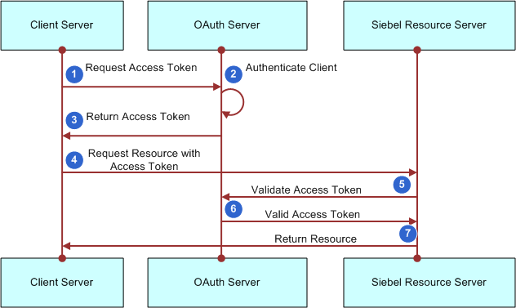

OAuth 2.0 defines a protocol, i.e. specifies how tokens are transferred, JWT defines a token format.
OAuth 2.0 and "JWT authentication" have similar appearance when it comes to the (2nd) stage where the Client presents the token to the Resource Server: the token is passed in a header.
But "JWT authentication" is not a standard and does not specify how the Client obtains the token in the first place (the 1st stage). That is where the perceived complexity of OAuth comes from: it also defines various ways in which the Client can obtain an access token from something that is called an Authorization Server.
So the real difference is that JWT is just a token format, OAuth 2.0 is a protocol (that may use a JWT as a token format).

Firstly, we have to differentiate JWT and OAuth. Basically, JWT is a token format. OAuth is an authorization protocol that can use JWT as a token. OAuth uses server-side and client-side storage. If you want to do real logout you must go with OAuth2. Authentication with JWT token can not logout actually. Because you don't have an Authentication Server that keeps track of tokens. If you want to provide an API to 3rd party clients, you must use OAuth2 also. OAuth2 is very flexible. JWT implementation is very easy and does not take long to implement. If your application needs this sort of flexibility, you should go with OAuth2. But if you don't need this use-case scenario, implementing OAuth2 is a waste of time.

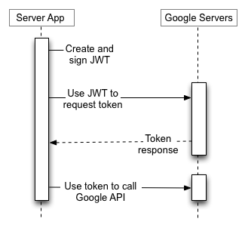

Spring Boot Application

Application : Spring_Boot_oauth_Auth_Reso_Server

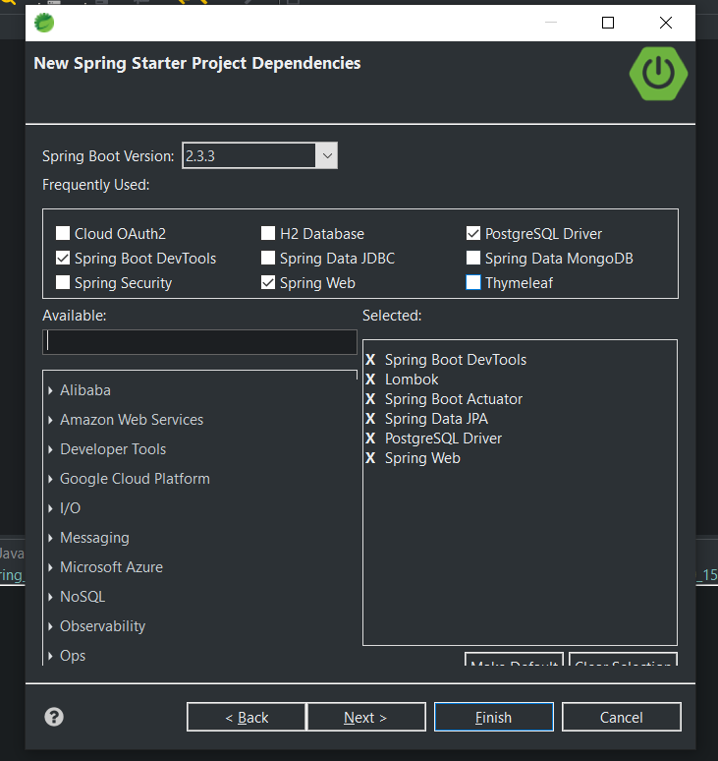

-Create Rest Controllers for POST and COMMENT with READ/WRITE operations.
- @Data is lambook Annotaion which creates
lombok.Data

@Entity
@Data
@AllArgsConstructor
@NoArgsConstructor
Generates getters for all fields, a useful toString method, and hashCode and equals implementations that check all non-transient fields. Will also generate setters for all non-final fields, as well as a constructor.
Equivalent to @Getter @Setter @RequiredArgsConstructor @ToString @EqualsAndHashCode.
Complete documentation is found at the project lombok features page for @Data.
See Also:
Getter
Setter
RequiredArgsConstructor
ToString
EqualsAndHashCode
lombok.Value

-- Add one-to-many Relationship to Post and Comment

